**MODULE 9 ASSIGNMENT**

**PROBLEM 2**

**PROBLEMS IN ERD DIAGRAM :**

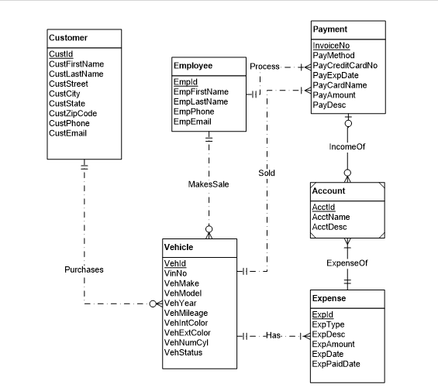

**REVISED ERD :**

